**STUDENT NAME**

**REG NUMBER**

**STEP ONE**

**Opening the Studio application**

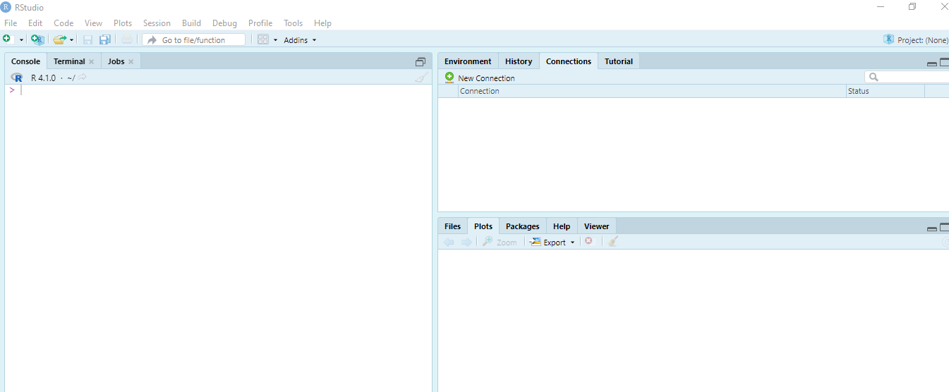

**STEP TWO**

**Plotting the unemployment graph**

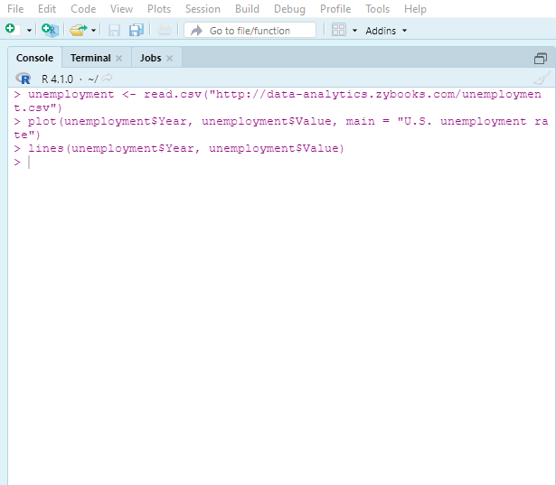

1. **Scatter plot**

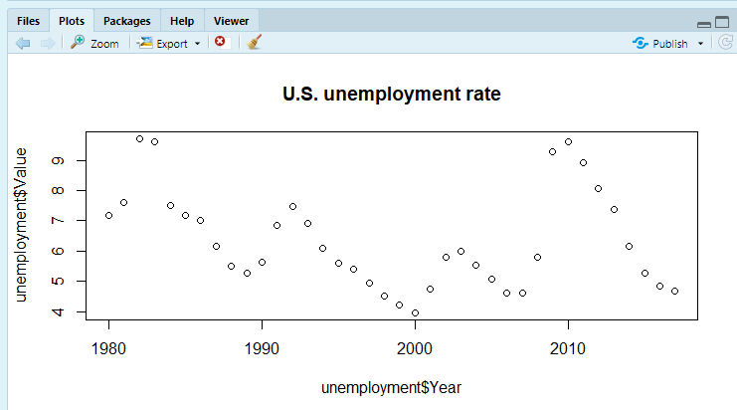

1. **Scatter and line plot**

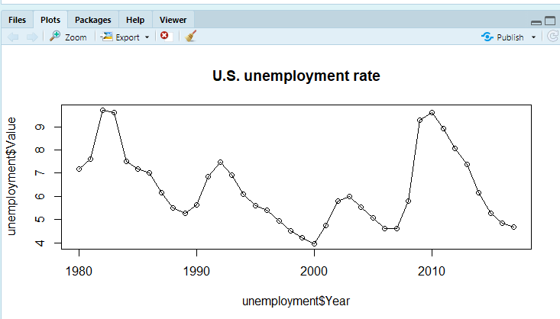

1. **Plot bar chart**

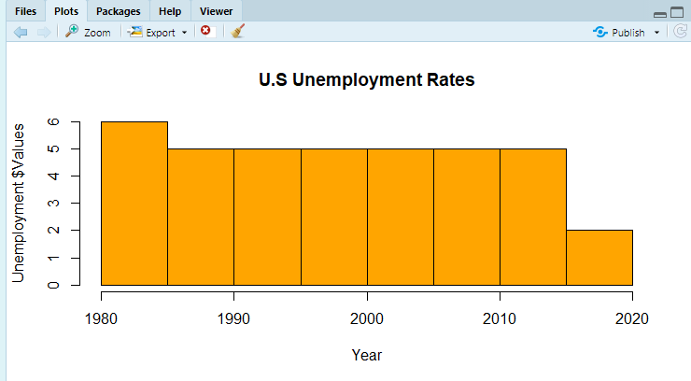

**REFLECTION AND DISCUSION**

In this assignment, I have fully understood the underlying capabilities of R and Studio development environment, upon which I have realised that this is a tool that can be used across cross functional and organizational analysis. The analyses drawn from these visualisations s will help teams and departments make meaningful derivations from their datasets. Some of the code if found interesting during this activity were:

* The ability to assign a variable from dataset and just like that be able to call this variable anywhere in the program toe execute the code

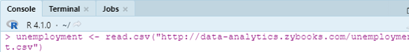

* The ability to visualise datasets based on calling inbuilt functions within R to visualise your data

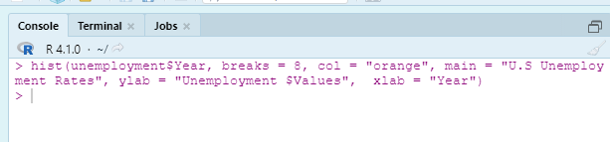

Based on the experience had with this software, it is easier to use for all skilled and new entry juniors who may not have a background to understand data and statistical visualisations, this is because the inbuilt functions are easier to call and utilise just by assigning the variable names and utilizing the inbuilt methods. I would most certainly recommend this tool to my manager because of its ease of use and the ability to visualise datasets from remote servers and with less tussle.

**Week Two**